**1. Using input() function take one number from the user and using ternary operators check whether the number is even or odd**

**PROGRAM:**

a = int(input("Enter number:"))

if a % 2 == 0:

print(f"{a} is even number")

else:

print(f"{a} is odd number")

**OutPut:**

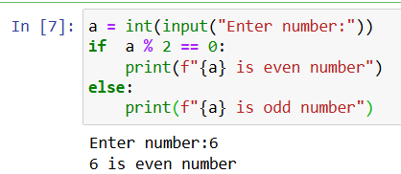 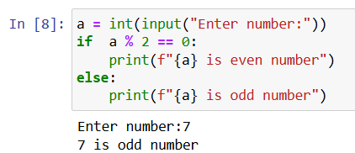

**2. Using input function take two number and then swap the number**

**PROGRAM:**

number1 = input(("enter first number: "))

number2 = input(("enter second number: "))

print(f' initial content number1 ={number1}, number2 ={number2}')

number1, number2 = number2, number1

print(f' After Swap number1 ={number1}, number2 ={number2}')

**OutPut:**

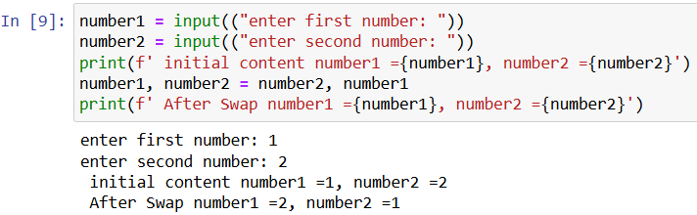

**3. Write a Program to Convert Kilometers to Miles**

**PROGRAM:**

KM = float(input('enter kilometers: '))

miles = KM*0.62137

print(f'{KM} km in miles is = {miles:.2f}')

**OutPut:**

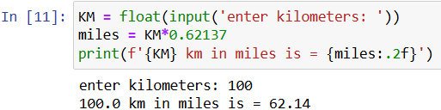

**4. Find the Simple Interest on Rs. 200 for 5 years at 5% per year.**

**PROGRAM:**

principal = float(input("Enter the principal amount: "))

rate = float(input("Enter the rate of interest (in %): "))

time = float(input("Enter the time (in years): "))

simple_interest = (principal * rate * time) / 100

print(f"The Simple Interest is: {simple_interest:.2f}")

**OutPut:**

